Current Bone Density order details:

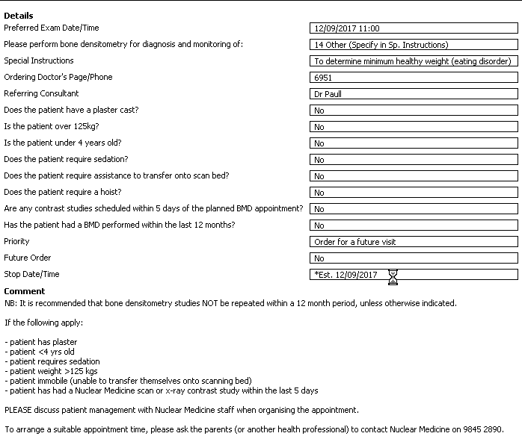

New Bone Density order details:



|  |  |
| --- | --- |
| Is the patient: |  |
| < 4 yrs old? | Yes/No |
| > 200 kg? | Yes/No |
|  |  |
| Does the patient: |  |
| Require sedation? | Yes/No |
| Need a hoist? | Yes/No |
| Have a plaster cast? | Yes/No |
| Have contrast studies planned < 5 days prior to the planned BMD appointment? | Yes/No |

**Comment:**

If you have answered “Yes” to any of the questions above, please discuss patient management with Nuclear Medicine staff prior to signing the order.

To arrange a suitable appointment time, please ask the parents (or another health professional) to contact Nuclear Medicine during business hours on 9845 2890.